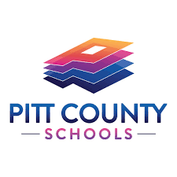

**PITT COUNTY SCHOOLS**

**EARLY COLLEGE HIGH SCHOOL**

Date: May 2023

Dear Parent/Guardian,

This letter is a reminder to pick up your child’s medication at the end of the school year, including asthma inhalers and epi-pens. School personnel will dispose of any medication remaining at the school after June 16, 2023. Students with permission to self-medicate can transport their asthma inhalers and epi-pens. Only an adult can take all other medications home.

Please remember to have your child’s doctor complete an Authorization of Medication Form over the summer months and return the form along with all medication on the first day of the 2023-2024 school year. This form is required for both short term and long-term prescription and over the counter medications. These forms are only valid for one year from the date originally signed.

Should you have any further questions or concerns regarding medication pick up or administration, please contact the school or school nurse.

Have a GREAT summer!

Wynn Whittington, Principal

Theresa Mills, School Health Care Manager